

Technical Memorandum
May 26, 2015
From: Lyle R. Chinkin, President
Re: 5-year AERMOD Simulation at the KCBX Terminals
This memorandum provides an overview of the 2009-2013 5-year AERMOD dispersion model simulation we performed to estimate concentrations of particulate matter with a diameter of 10 micrometers or less (PM₁₀) in the vicinity of the KCBX Terminals due to PM₁₀ emissions from both the North and South Terminal facilities.
For the 5-year period modeled, 99% of the 24-hr average PM₁₀ concentrations predicted for monitor locations at the North and South Terminals were below 50 μg/m³. These results are consistent with PM₁₀ measurements collected at the KCBX Terminals since February 2014, which indicate that 89% of 24-hr average PM₁₀ concentrations are below 50 μg/m³ (note that measured concentrations reflect the impact of both on-site and off-site sources, while the modeled concentrations reflect only on-site sources).
For peak impacts, the maximum 24-hr average PM₁₀ concentrations predicted by AERMOD at the North Terminal fence line was 115 μg/m³, while the peak impact at the South Terminal fence line was 70 μg/m³. At residential locations beyond the terminal fence lines, maximum 24-hr average concentrations predicted by AERMOD were 54 μg/m³ at residences near the North Terminal and 26 μg/m³ at residences near the South Terminal. These values demonstrate that PM₁₀ concentrations associated with fugitive dust from the KCBX terminals decrease rapidly with distance from the facility.

Model Setup
We set up AERMOD to model dispersion of PM₁₀ emissions from all sources included in routine emissions reports prepared for the KCBX Terminals, including vehicle traffic, windblown erosion from material stockpiles, and material handling and transfers. The model was configured for flat terrain in an urban setting. Additional details about the model representation of sources, receptor network, and meteorological input for the simulation are provided below.

PM₁₀ Emissions
The PM₁₀ emissions data modeled in AERMOD were based on monthly PM₁₀ emissions reports prepared for the KCBX North and South Terminals. For the South Terminal, monthly emissions data were only available for 2013, so the 2013 emissions data were used for all five years modeled (2009-2013), with only meteorological data varying from year to year. For the North Terminal, monthly emissions data were available for the years 2008-2013. However, data from 2013 were selected for use in the AERMOD runs. This decision was made for the following reasons:
- 2013 represents the most recent year of complete data and reflects current operations at the North Terminal;
- 2013 emissions were 14% to 55% higher than emissions from any other year in the 2008-2013 period, as shown in Figure 1; and
- Using 2013 emissions for the North Terminal made the modeling approach consistent with the approach for the South Terminal, for which only 2013 emissions were available.
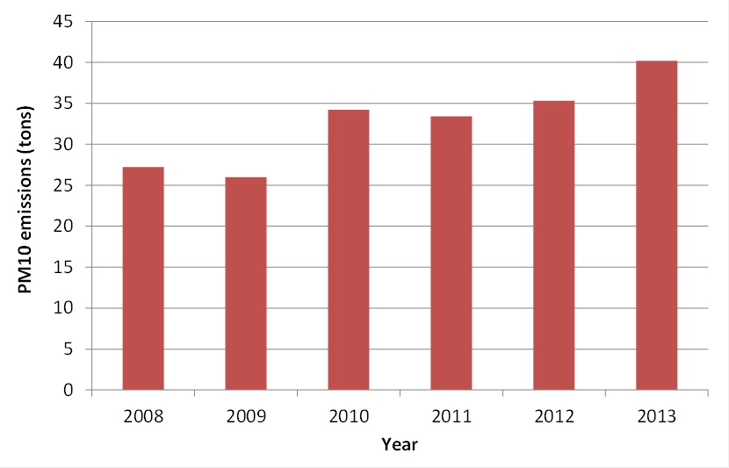
Figure 1. Annual PM₁₀ emissions at the KCBX North Terminal, 2008-2013.
The PM₁₀ emissions were reported for four main source categories: (1) fugitive dust from vehicle activity; (2) wind erosion from material piles; (3) material handling processes; and (4) combustion sources (e.g., generators). Figure 2 shows the contribution of each source category to total 2013 emissions at the North and South Terminals. At both terminals, fugitive dust from vehicle activities is the dominant PM₁₀ source, accounting for over 80% of the total emissions. Windblown erosion from the material piles accounts for 8% of the total PM₁₀ emissions at the North Terminal and 13% of the total PM₁₀ emissions at the South Terminal.
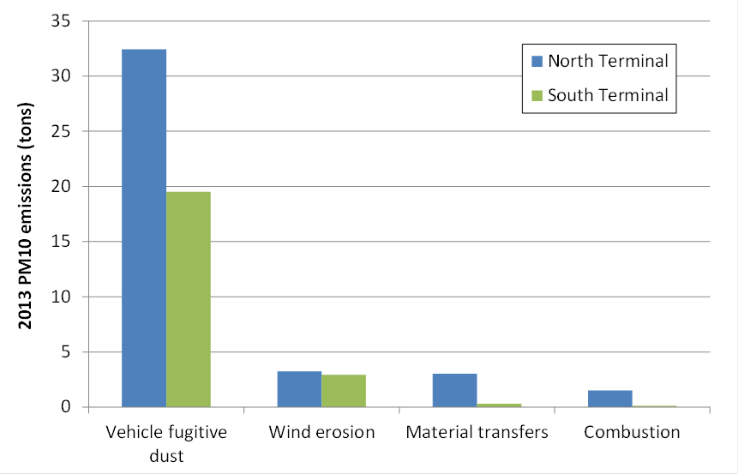
Figure 2. 2013 PM₁₀ emissions by source category at the KCBX Terminals.

Source Configurations
The configuration of sources was based on information received from KCBX operators and observations during our site visits. All source categories were represented in the AERMOD simulation as area sources, except fugitive wheel dust, which was represented by series of adjacent volume sources along pathways representative of vehicle movement within the Terminals (e.g., bulldozers moving material piles). The source configurations at the North and South Terminals for the 5-year simulation are shown in Figures 3 and 4.
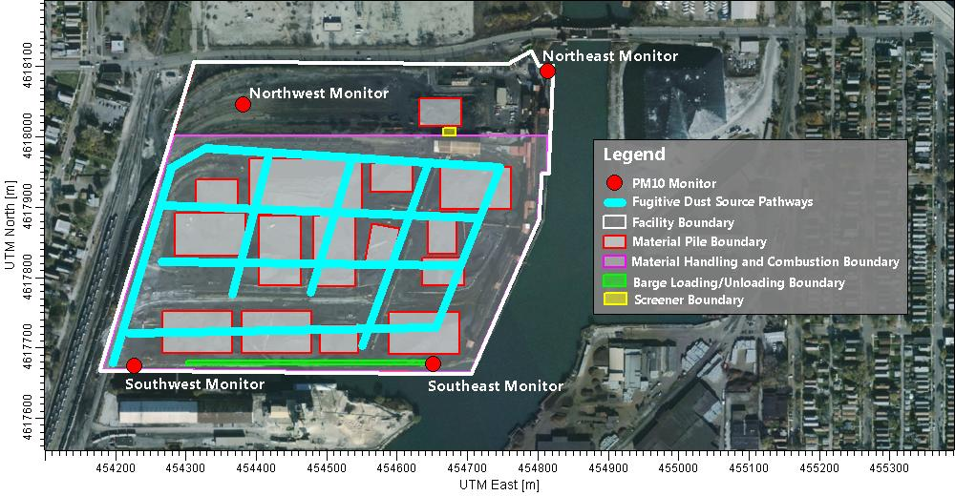
Figure 3. Configuration of modeled PM₁₀ emissions sources at the KCBX North Terminal.
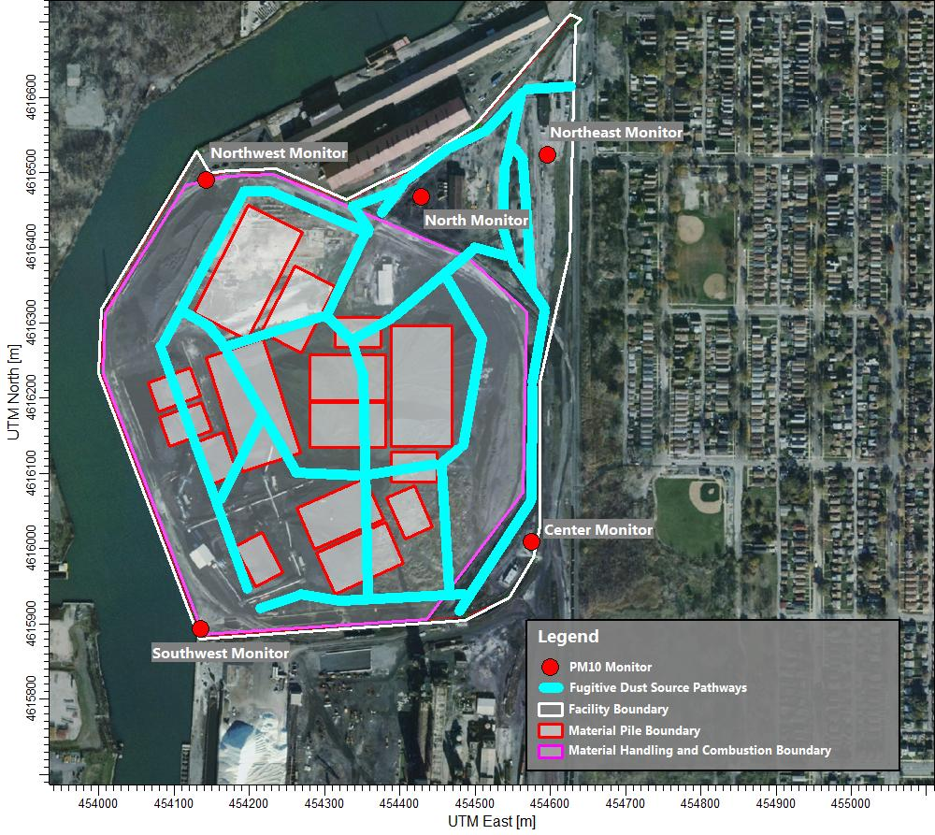
Figure 4. Configuration of modeled PM₁₀ emissions sources at the KCBX South Terminal.

Receptors
The AERMOD modeling domain was centered between the North and South Terminals, extending approximately 1.5 miles in the east-west direction and 2.5 miles in the north-south direction. A network of receptors was defined in a nested grid arrangement to provide fine resolution (50 m spacing up to 550 yards from the Terminal boundaries) of predicted PM₁₀ concentrations near the KCBX Terminals, and coarser resolution (100 m) at greater distances from the Terminals. We also defined fence line receptors at 25 m spacing along the property boundaries, and additional receptors at the PM₁₀ monitoring locations.

Meteorology
Meteorology inputs for the AERMOD simulation were developed using representative data measured during the five modeled years: surface data from Chicago Midway Airport (KMDW) and upper air data from Davenport Airport (KDVN) in Iowa. The meteorology input also accounted for monthly land surface characteristics, which were developed using snow cover and historical precipitation data measured at KMDW, and data from the National Land Cover Database.

Model Results
For the 5-year period modeled, 99% of the 24-hr average PM₁₀ concentrations predicted for monitor locations at the North and South Terminals were below 50 μg/m³. These results are consistent with PM₁₀ measurements collected at the KCBX Terminals since February 2014. Over 13 months of PM₁₀ measurements are available from 9 monitoring stations at the North and South Terminals, and 89% of the measured concentrations are below 50 μg/m³ (see Figure 6). Note that the PM₁₀ measurements include impacts from both on-site and off-site emissions sources, while the modeled concentrations include only on-site sources.
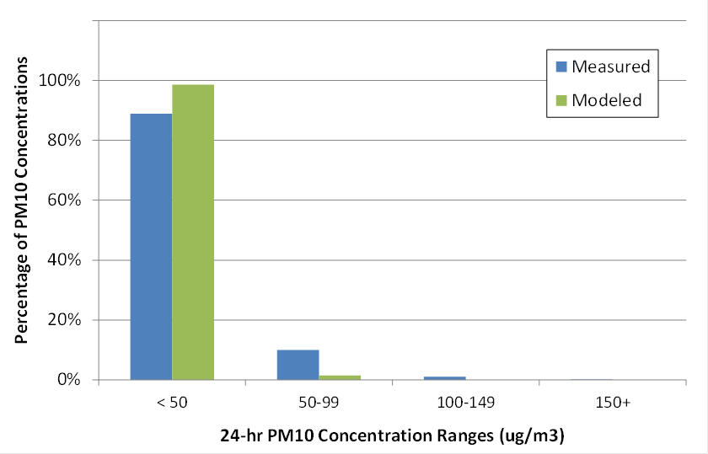
Figure 5. Comparison of measured and modeled PM₁₀ concentrations at the KCBX Terminals.
Table 1 on the next page shows peak impacts from the 5-year AERMOD simulation. The maximum predicted 24-hr PM₁₀ concentrations for various years in the period modeled range from
- 105 to 115 μg/m³ at the North Terminal fence line;
- 62 to 70 μg/m³ at the South Terminal fence line;
- 44 to 54 μg/m³ at North Terminal residential receptors; and
- 23 to 26 μg/m³ at South Terminal residential receptors.
The highest value shown in Table 1 is the maximum concentration at the North Terminal fence line (115 μg/m³), which occurred in September 2009. The maximum concentration at the South Terminal fence line of 70 μg/m³ occurred in October 2011.
Table 1. Maximum 24-hr average PM₁₀ concentrations predicted by AERMOD.
 | Maximum 24-hr Average PM₁₀ Concentration (μg/m³)
 | North Terminal |  | South Terminal
Year | Fence Line | Residential | Fence Line | Residential
2009 | 115 | 54 | 62 | 24
2010 | 105 | 44 | 66 | 26
2011 | 110 | 45 | 70 | 23
2012 | 112 | 47 | 65 | 24
2013 | 113 | 47 | 66 | 25

Note that 9 Federal Equivalent Method (FEM) PM₁₀ monitors have been operating at the KCBX Terminals since February 2014. Four monitors are at the North Terminal, and five monitors are at the South Terminal.

